**NAME – PRITAM DAS** 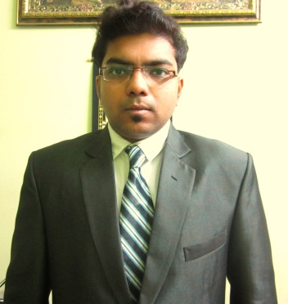

**FATHER’S NAME – PRABHAT KR DAS**

**ADDRESS – 30/24/1 ATTA PARA LANE, KOLKATA-700050**

**Email:** pritamdas_pd999@yahoo.in **Contact no:7278775999**

**Career Objective**: To work in a challenging environment and contributing both to self as well as organization’s growth.

**EDUCATIONAL QUALIFICATIONS**

|  |  |  |  |
| --- | --- | --- | --- |
|  | INSTITUTE | PERCENTAGE/ CGPA | YEAR |
| PGDM+MBA | International School of Business, Kolkata | 6.1% | 2011-13 |
| GRADUATION (BBA) | Jis college of engineering | 63.3% | 2011 |
| CLASS XII (H.S) | B.N.N.V | 59% | 2008 |
| CLASS X (MADHYAMIK) | B.N.N.V | 63% | 2006 |

**SPECIALISATION: MAJOR – MARKETING / MINOR – FINANCE**

**SUMMER INTERNSHIP**

Company Area of Study (From when to when)

**PANTALOONS (FUTURE GROUP) Marketing &Operations 27th may to 27th June (2012)**

**OBJECTIVE:** A Project given to me was to promotion of pantaloons loyalty programme which means promotion of pantaloons pay back card, transfers green card to new pay back card and operation of logistic

**PROFESSIONAL EXPERIENCE:**

**UNITED –E –SERVICES (E-BAY INDIA ) (2013- 2015)**

**DESIGNATION- Senior Marketing Executive**

**Responsibility – Brand promotion, Product promotion. Sales.**

**Bharti Airtel Limited ( Thinktel Solutions India Pvt Ltd) (2016 – Present)**

**DESIGNATION – Relationship Manager (corporate)**

**Responsibility – Sales, Customer Service, Service Promotion, Bill Collection,**

**KEY PROJECTS UNDERTAKEN**

* Visited the Vizag Steel Plant feb’2012,and prepared a industry tour report presentation on supply chain management and presented it before the judges at ISB Kolkata
* Visited a Food restaurant in Kolkata and prepared a project on how they set up their location, preparing of food, storing of raw materials in KFC Kolkata.
* Poster presentation of Business Idea Tuhina beauty cream ISB Kolkata 2012.

Visited the Berger paint november’2012, and prepare a industry report .

**CONFERENCES & SEMINARS ATTENDED**

* Attended the Seminar of Risk Management in ISBM, Jan2012

**ACHIEVEMENTS & RECOGNITION**

* Achieved a Certificate by NEN .
* Achieved a Certificate by PANTALOONS (FUTURE GROUP) after Summer Internship.
* Achieved a certificate by NIIT.

**EXTRACURRICULAR ACTIVITIES**

* Achieved certificates from playing tabla and drama.
* Achieved computer certificate from IBM.

**COMPUTER PROFICIENCY**

* MS Word
* MS Power point
* MS Excel

SIGNATURE DATE